lab 5 - Proof of Concept (POC)
Generated from the provided screenshots and notes.

Step 1
delete carlos account
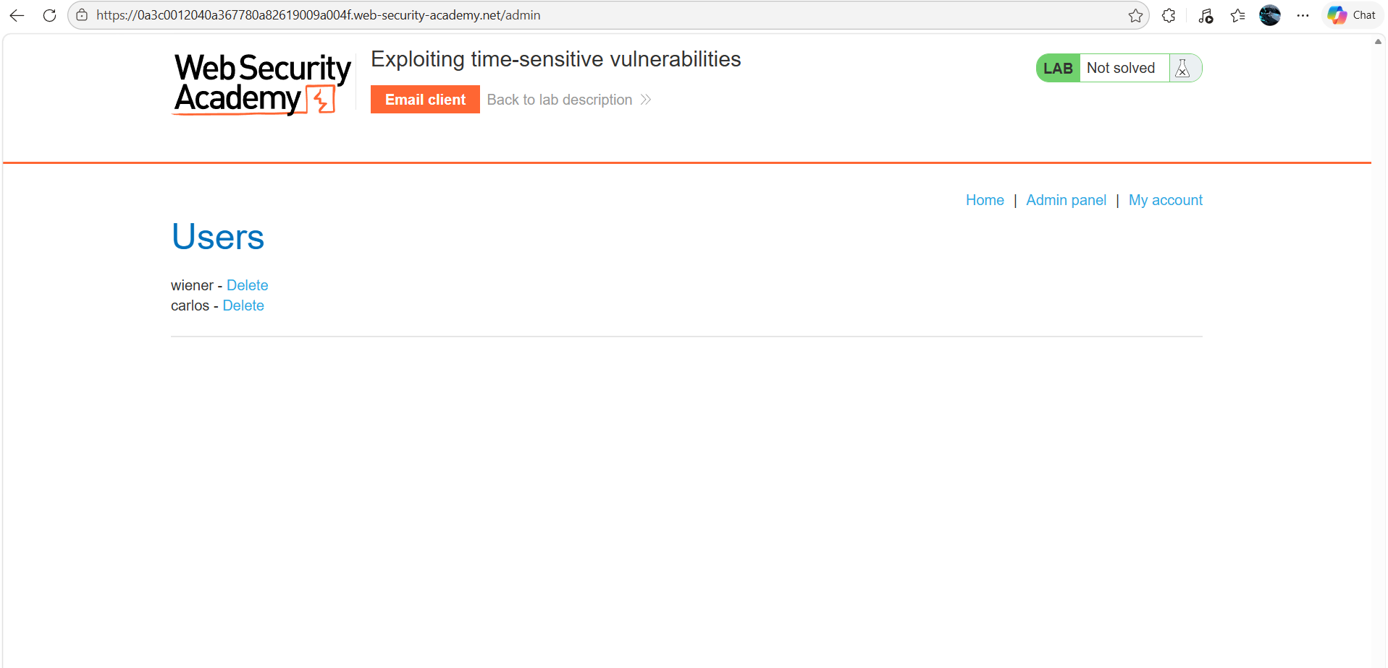

Step 2
diffetent request send to the different session and csrf tocken
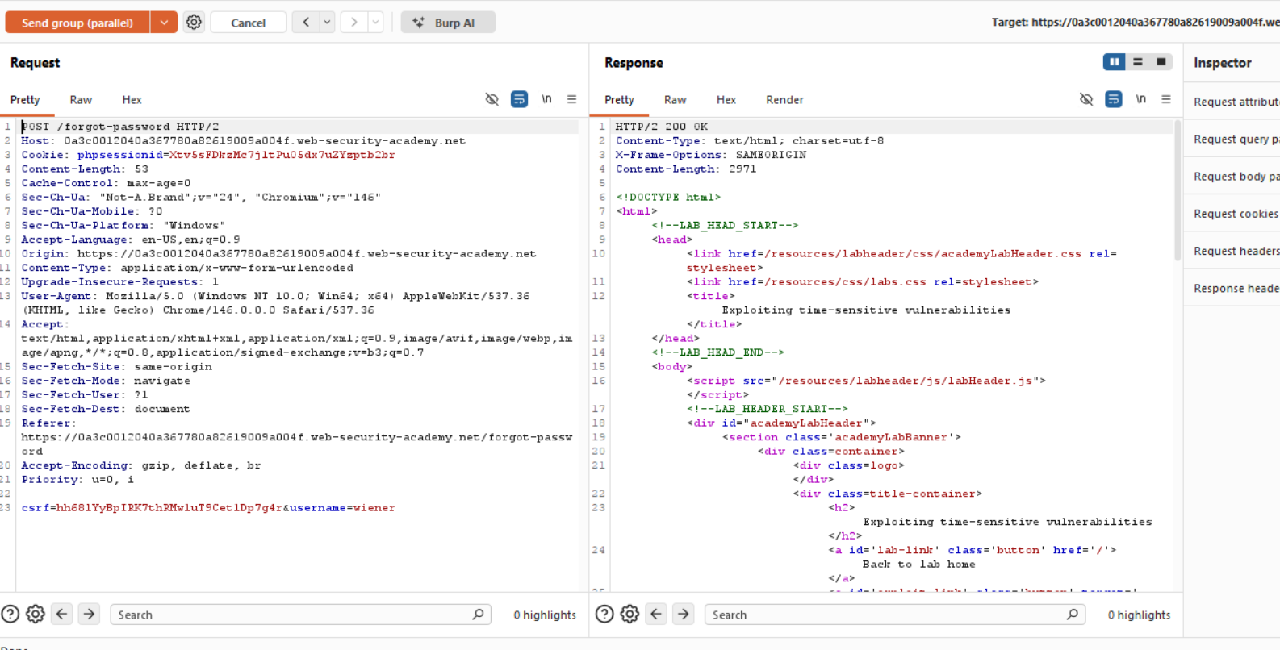

Step 3
edit url wener into carlos
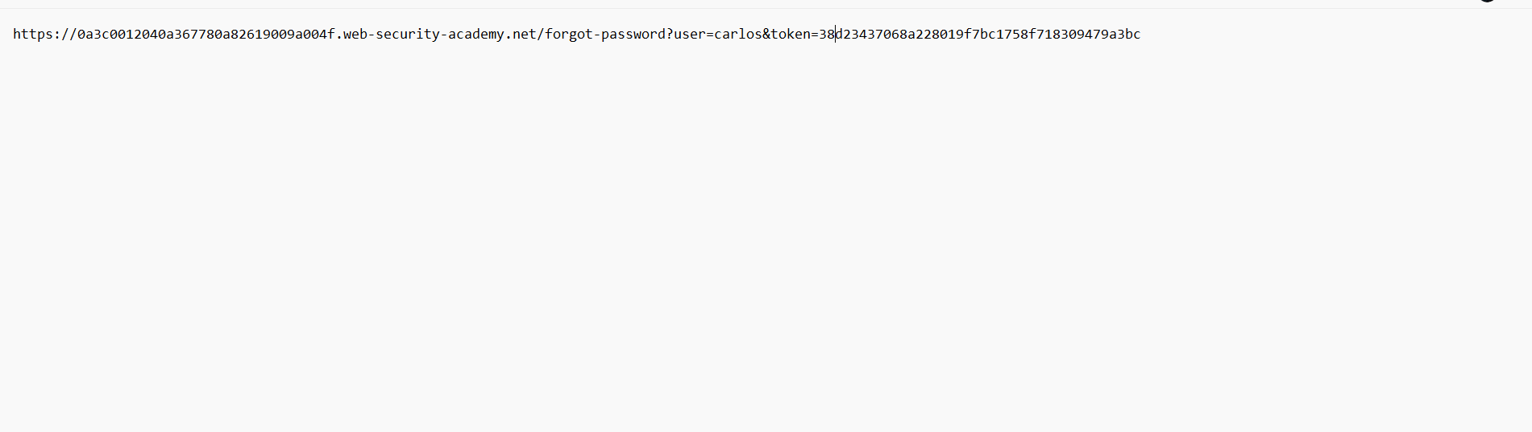

Step 4
get request send to the repeter
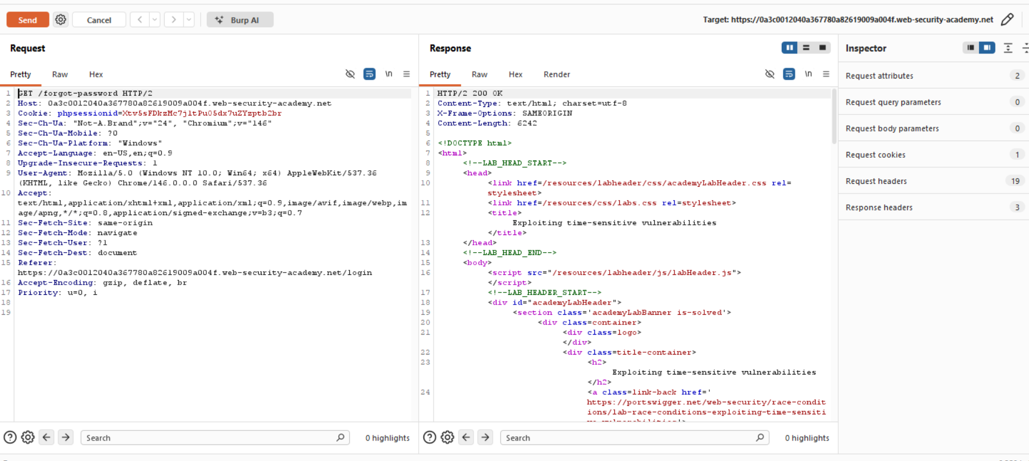

Step 5
get the carlo accunt
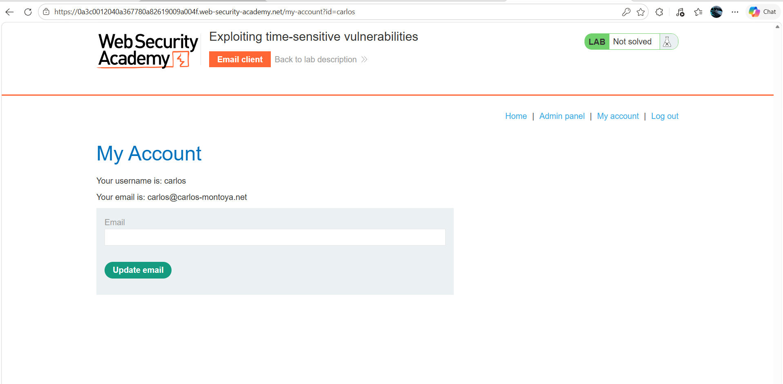

Step 6
in the grp 1st post request change the session coocies abd csrf tocken which you get get request
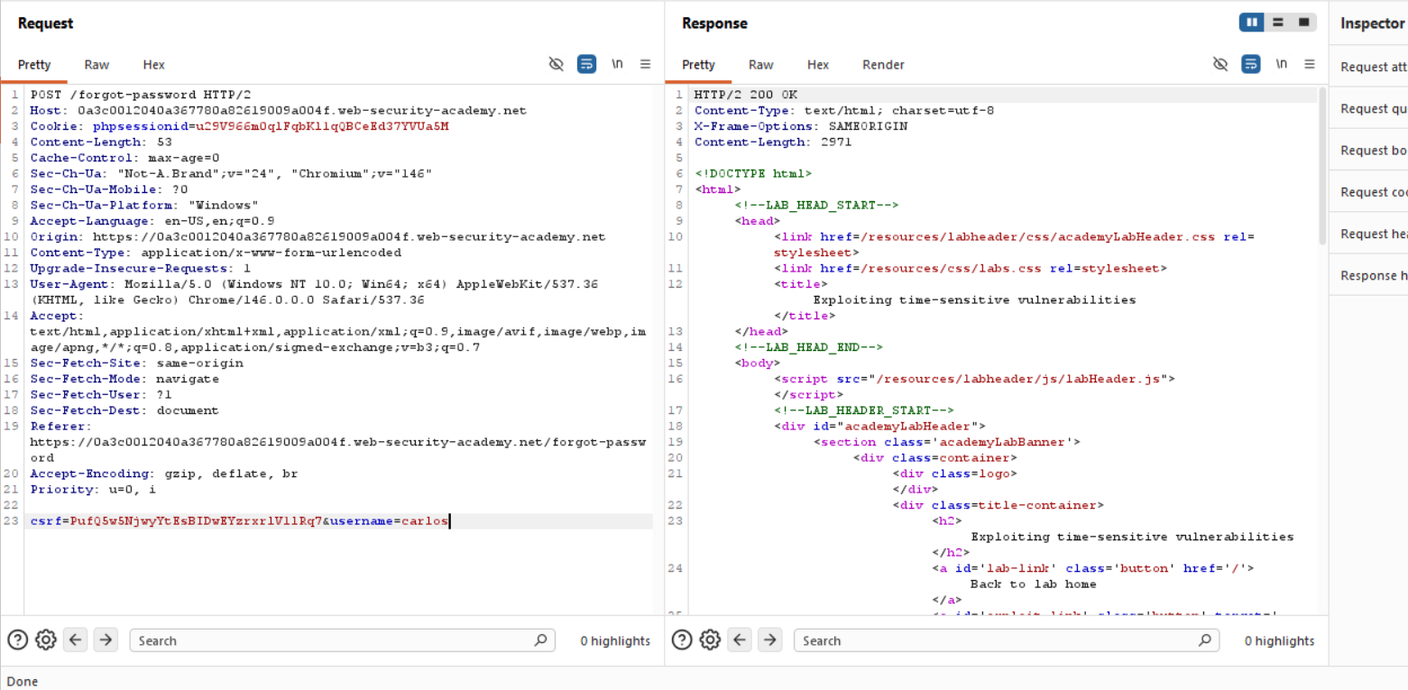

Step 7
make the grp both 2 post forget
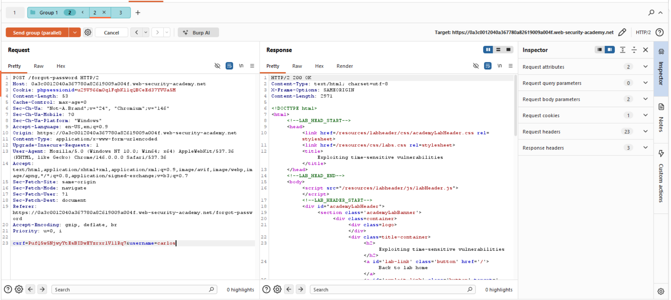

Step 8
remove the session section fromthe request GET request so it generate a new session every send time
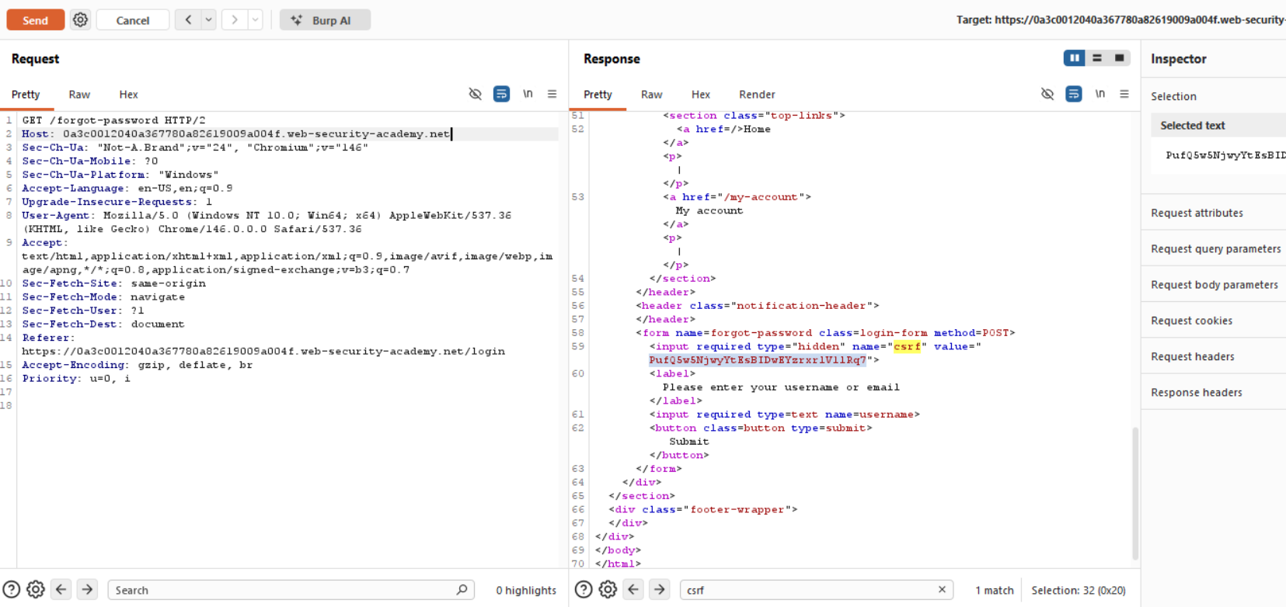

Step 9
take lettest request link copy it and change the nam ewener tinto carlos and run in browser
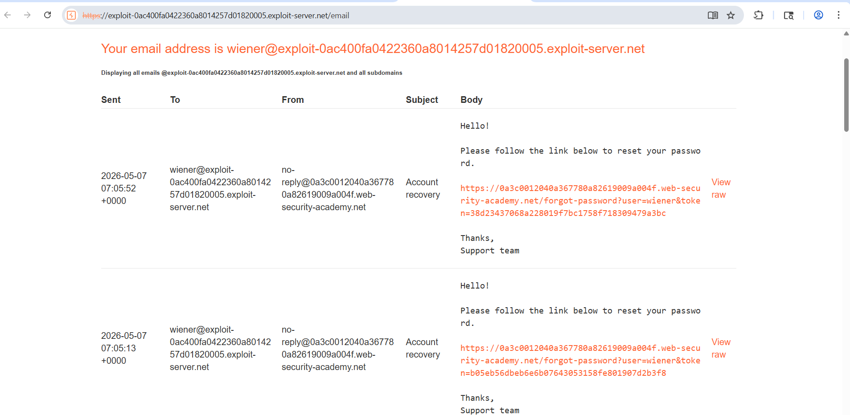

Lab Solved
lab sloved
